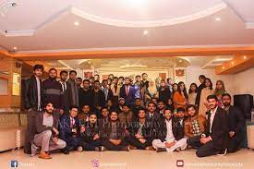
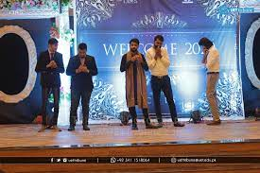
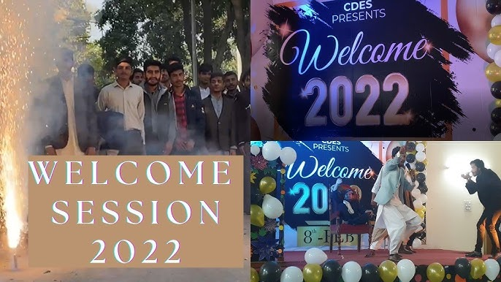
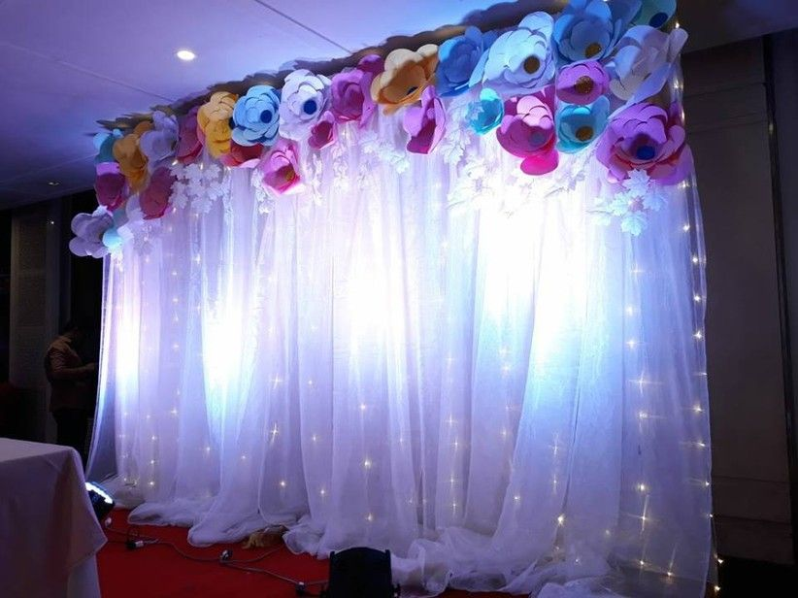

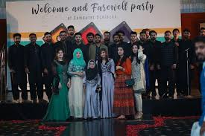
Wish you a best of luck for future.
Juniors...
Enjoy your journey
Congratulations on coming here.
Welcome!
AT SATURDAY 12:00
UNIVERSITY OF ENGINEERING AND TECHNOLOGY LAHORE
WELCOME PARTY 2023

